Charlie Nitschelm

Pressure Lab

3/26/19

The natural frequency and the damping ratio were extracted from the data using fundamental equations assuming a second order differential system. The damping ratio was calculated by locating all of the major peaks from the data file and using those values as inputs into the damping ratio

$$ζ= \frac{\frac{1}{n-1}ln({\frac{y_{1}}{y_{n}})}}{\sqrt{4π^{2}+\frac{1}{n-1}\ln{(\frac{y_{1}}{y_{n}}})}}$$

The equation above provides a list of damping ratios for each peak observed in the data sets obtained, including the valve and balloon sets. A mean is then obtained for each data set that displays the predicted overall damping ratio of the system.

Once the damping ratio was determined, the natural frequency of each data set can be determined. To do this, the time of each peak was recorded and used to find the period of the cycle. The period constant can then be inputted into the equation for the damped natural frequency:

$$ω_{d}= \frac{2π}{Period}$$

Finally, the damping ratio and damped natural frequency can be the inputs to the natural frequency equation

$$ω_{n}= \frac{ω_{d}}{\sqrt{1-ζ^{2}}}$$

Both the damping ratio and the natural frequency of each data set can then be implemented to predict the output of a system given its initial conditions and simulate an arithmetic solution to the curve.

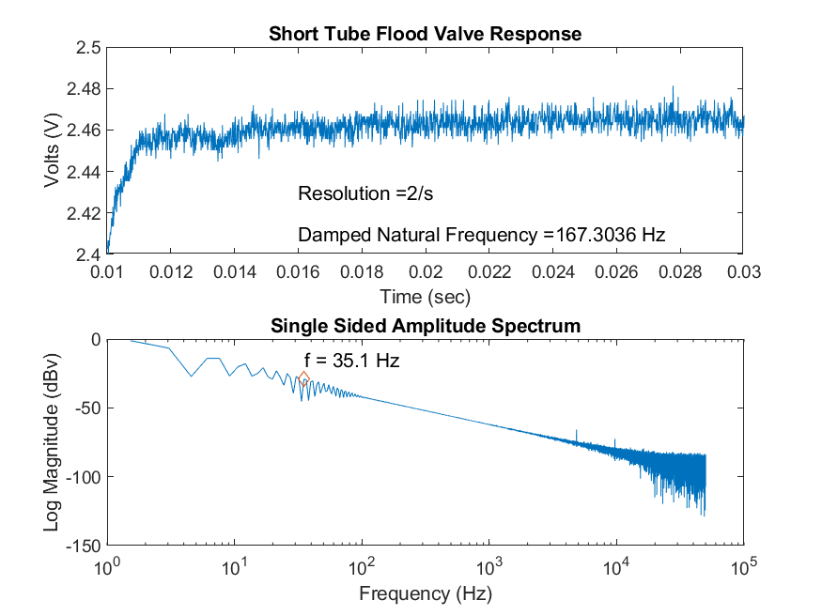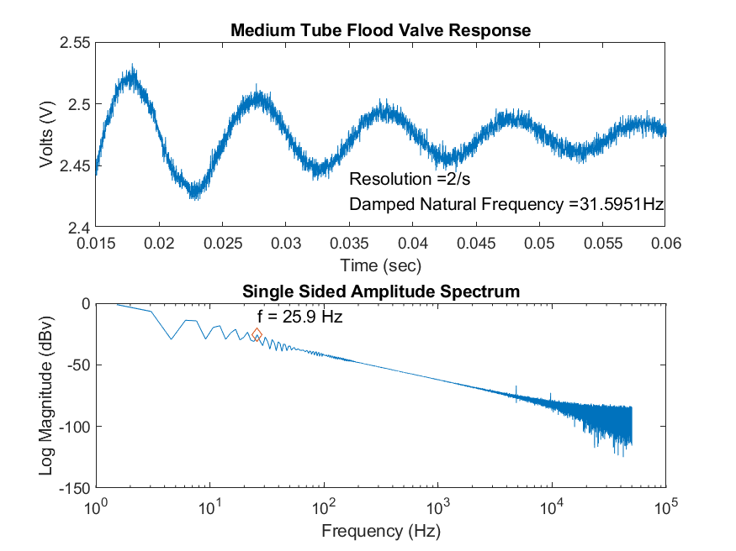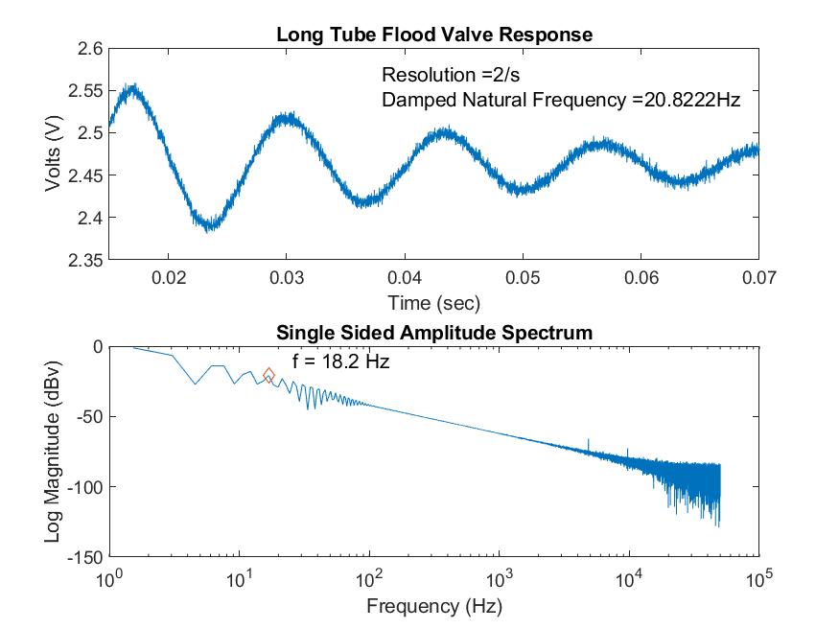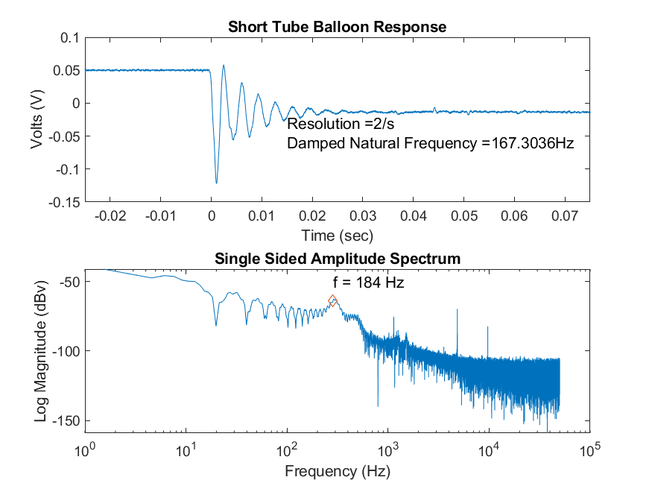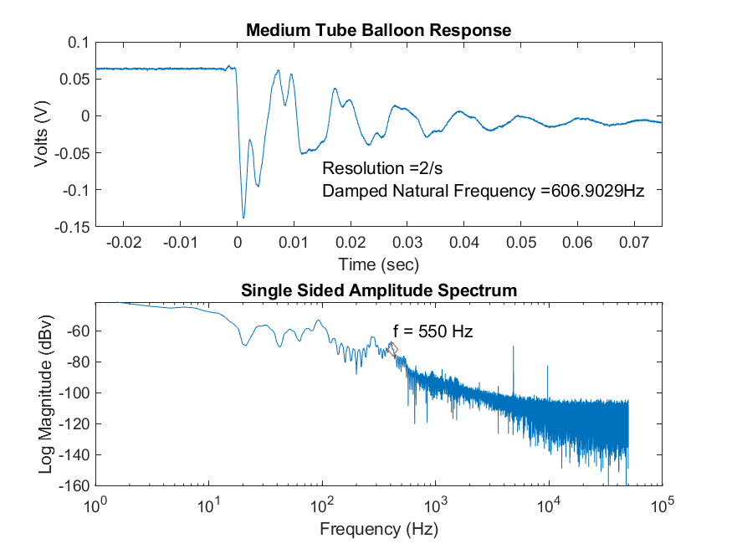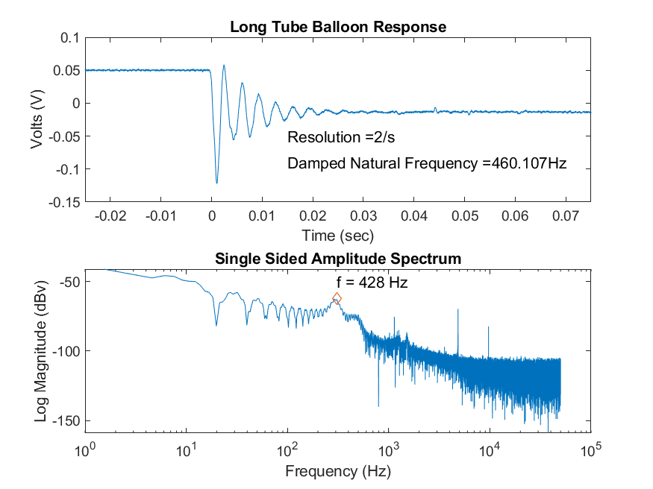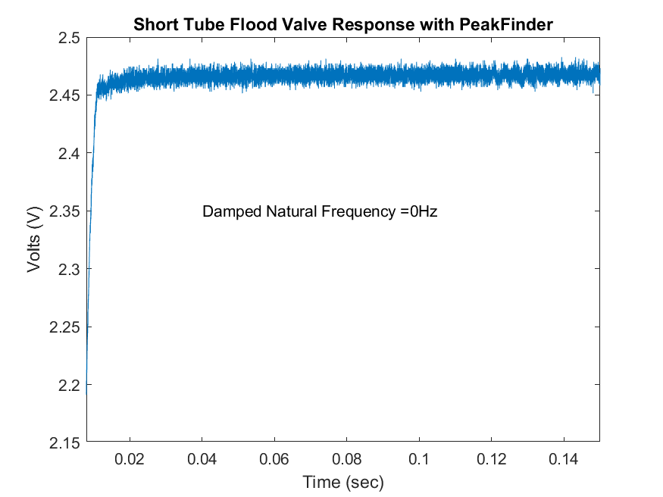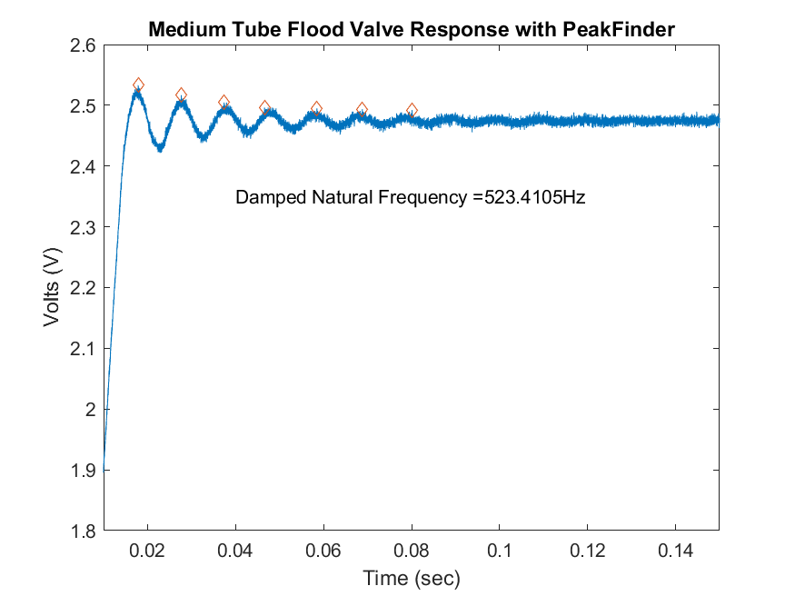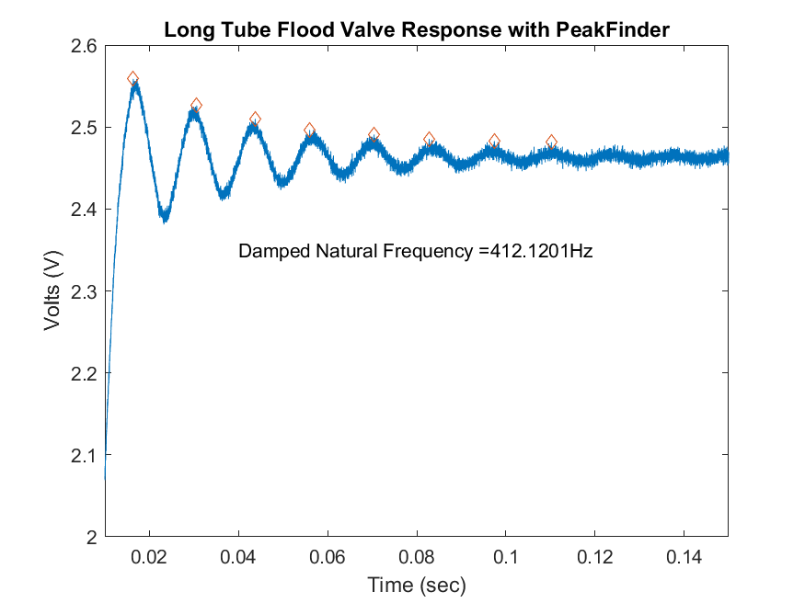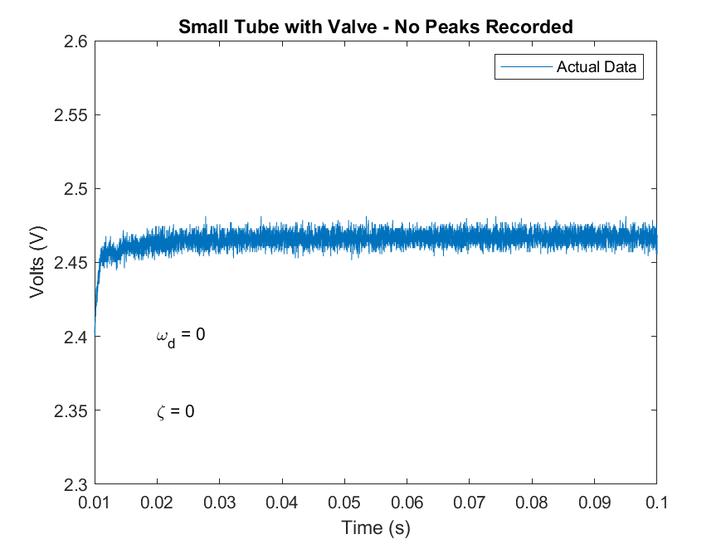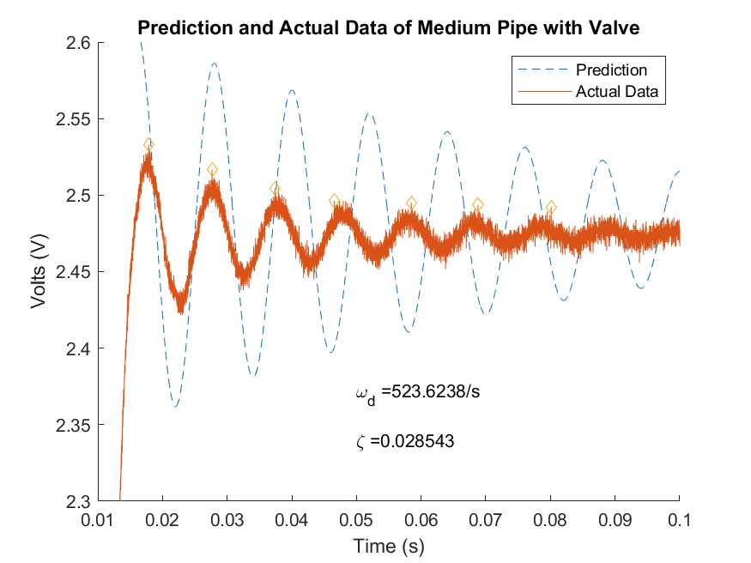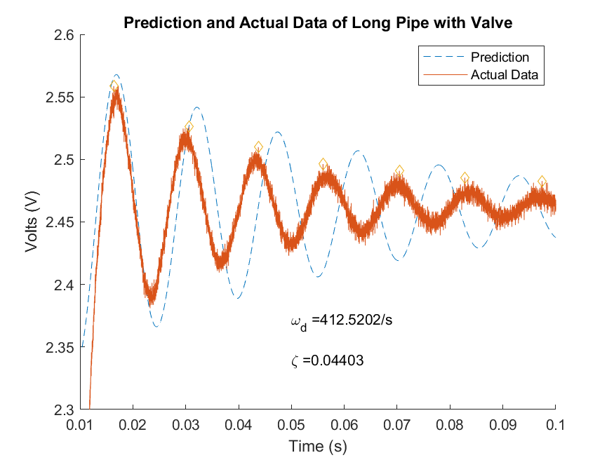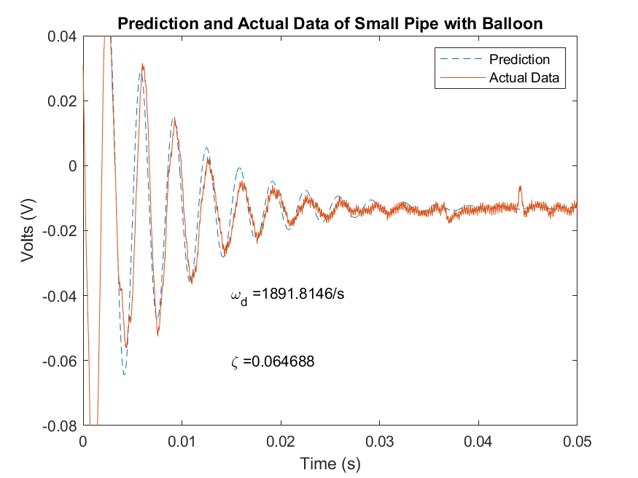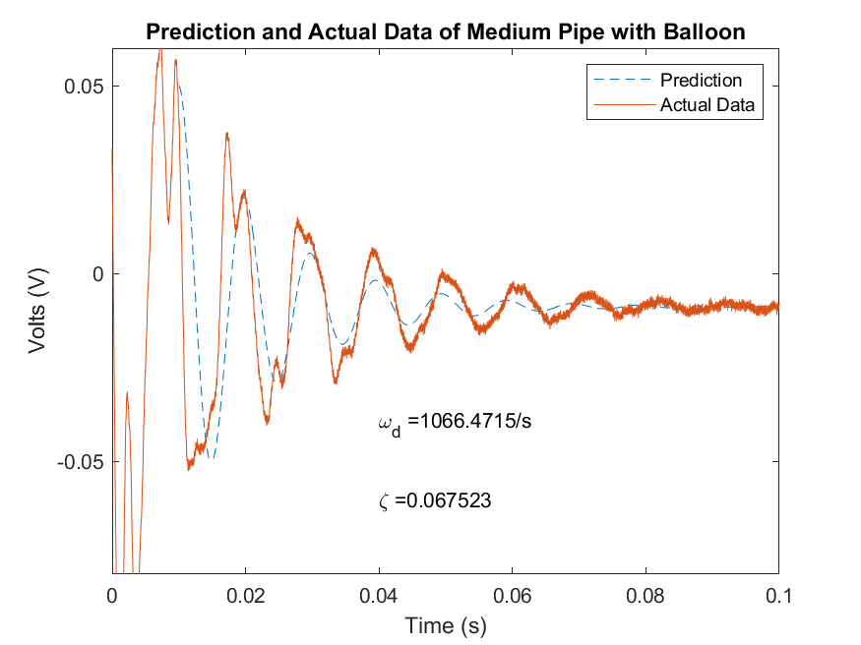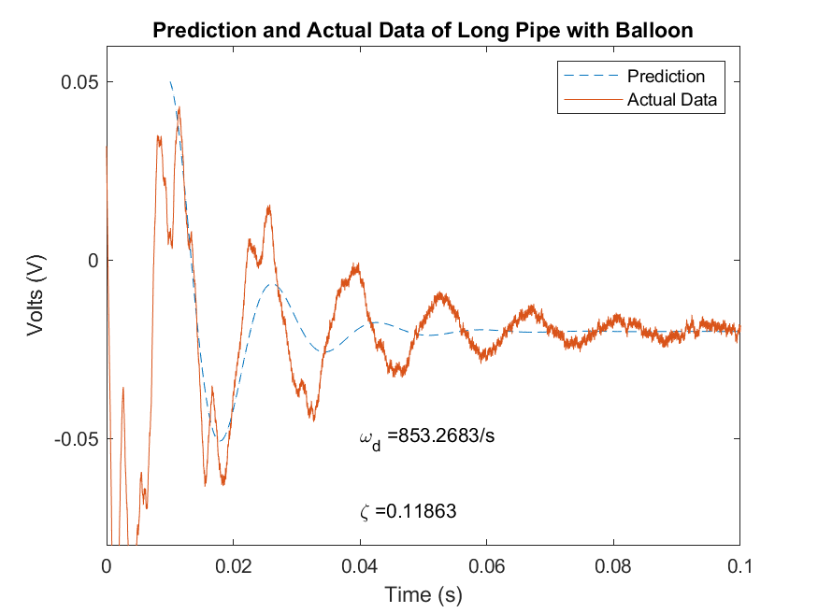

Two fundamental equations were used to calculate a curve to attempt to match with the calculated damping ratio and natural frequencies of each system analyzed. The equation for natural frequency is

$$ω_{n}= \frac{a}{l\sqrt{0.5+\frac{V}{V_{t}}}}$$

Where a is the speed of sound, 343 m/s, l is the length of the tube used for the test, V is the volume of the pressure transducer, and $V_{t}$ is the volume of the tube used. By knowing the inputs, a prediction graph could be calculated to obtain a graphical display of predicted and actual natural frequencies.

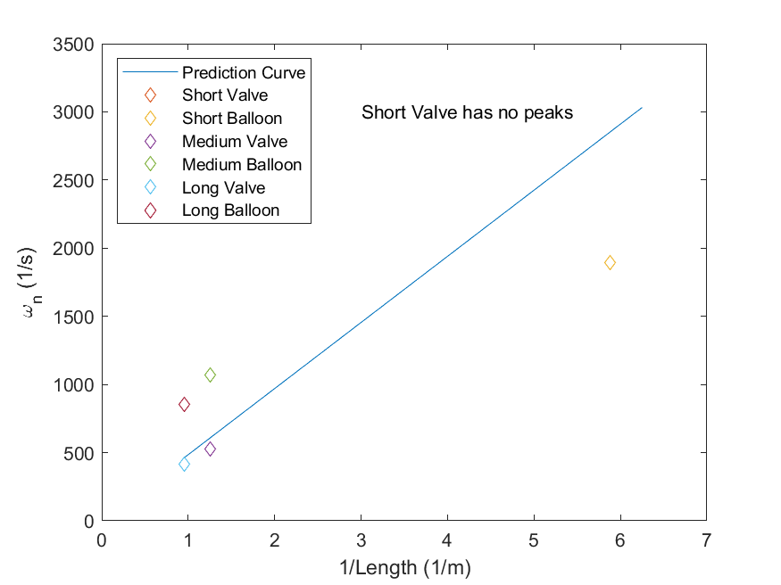

There is a clear linear relationship between natural frequency and the inverse of the tube length. The actual precision of the data to the curve is within +- 500/s for the longest and the second longest tube, while the short tube exhibits and error closer -1000/s. With any data set, a significant amount of error can exist. Within the pressure experiment, the valve data especially exhibited a larger error as the change in voltage from the pressure sensor was quick and large. Second order systems are also known to be difficult to precisely predict an appropriate curve.

The equation for natural frequency is

$$ζ= \frac{16μl}{aρd^{2}}\sqrt{0.5+ \frac{V}{V_{t}}}$$

Where $μ$ is kinematic viscosity, 1.81 ${10}^{-5}$\* kg/ms, l is the length of the tube used for the test, V is the volume of the pressure transducer, and $V_{t}$ is the volume of the tube used, a is the speed of sound, 343 m/s, $ρ$ is the density of air, 1.225 kg/ $m^{3}$, and d is the diameter of the tube used. By knowing the inputs, a prediction graph could be calculated to obtain a graphical display of predicted and actual damping ratios.

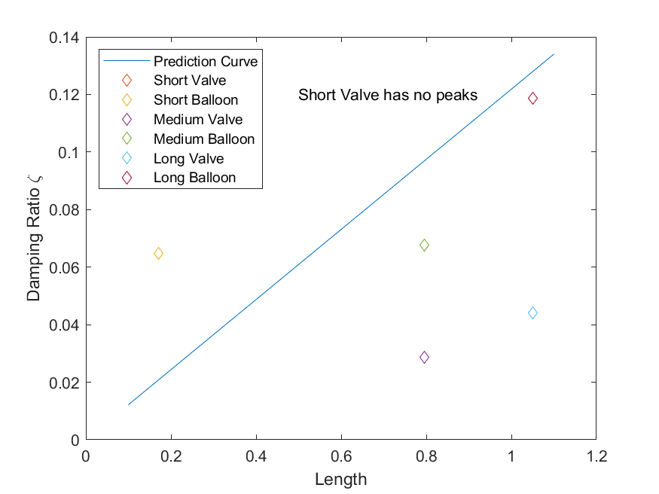

There is a clear linear relationship between the damping ratio and the tube length. The actual precision of the data to the curve is within an order of magnitude for the longest and the second longest tube, while the short tube exhibits and error closer to half and order of magnitude. With any data set, a significant amount of error can exist. Within the pressure experiment, the valve data especially exhibited a larger error as the change in voltage from the pressure sensor was quick and large. Second order systems are also known to be difficult to precisely predict an appropriate curve.